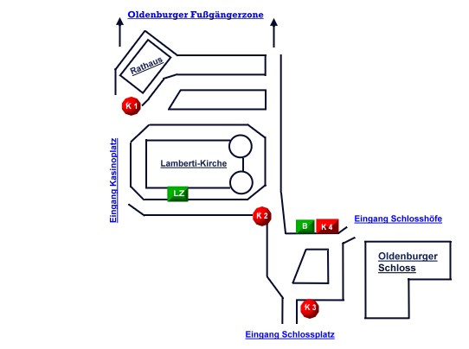

|  |  |  |  |  |  |  |
| --- | --- | --- | --- | --- | --- | --- |
|  | | |  |  | |  |
| Mondorf "Märchenkarussell | | | K 1 | Hempen „Weihnachtskarussell“ | | K 2 |
| Lesnik “Weihnachtskarussell" | | | K 3 | Meinecke "Weihnachts-Rad" | | K 4 |
|  | | |  |  | |  |
| Märchen-Lesezelt | | | LZ | Bühne | | B |
|  | | |  |  | |  |
|  | | |  |  | |  |
|  | | |  |  | |  |
|  | |  |  |  | |
|  | |  |  |  | |
|  | |  |  |  | |
|  | |  |  |  | |
|  | |  |  |  | |